––––––––Week-2
- a) Create and attach an EBS volume to an EC2 instance, and
- scale the instance by increasing CPU and RAM by changing the instance type.
2.Attach and permanently mount an EBS volume to a Linux EC2 instance to ensure data persistence across reboots.
3. Create a snapshot of the attached EBS volume and use it to create and attach a new volume to an EC2 instance in another AWS region.

- a) Create and attach an EBS volume to an EC2 instance, and
- scale the instance by increasing CPU and RAM by changing the instance type.

- Creating andattaching an EBS volume to an EC2 instance
Step 1: Create a New EBS Volume
Open the EC2 Dashboard.
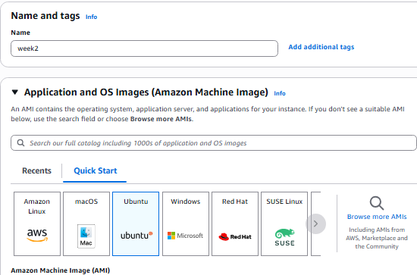

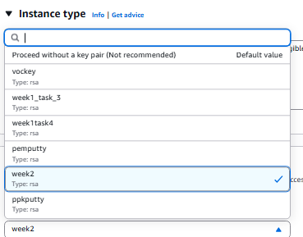

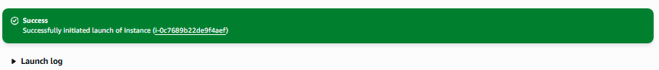

From the left-hand menu, select Volumes under Elastic Block Store (EBS).
Click Create Volume.
Choose:
Volume type (gp3/gp2)
Size of the volume
Availability Zone (must be the same as the EC2 instance)
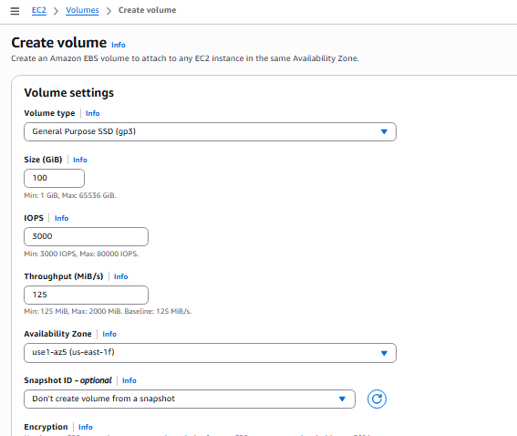

Click Create Volume.
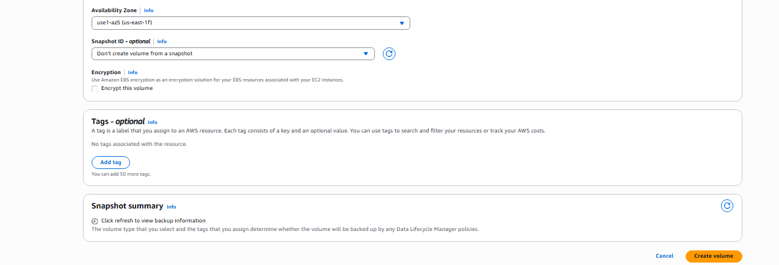

Step 2: Attach the EBS Volume to the Existing EC2 Instance
In the Volumes section, select the newly created volume.
Click Actions → Attach Volume.
Select the target EC2 instance from the list.
Specify the device name (example: /dev/xvdf).
Click Attach.
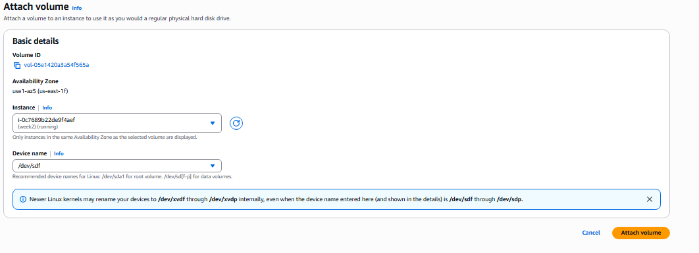

Step 3: Verify the Volume on the EC2 Instance
Connect to the EC2 instance using SSH.
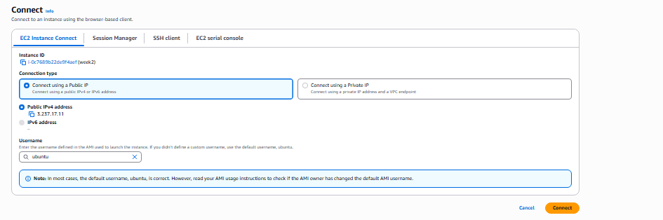
Check the attached disks:
lsblk
Identify the new volume (e.g., /dev/xvdf).
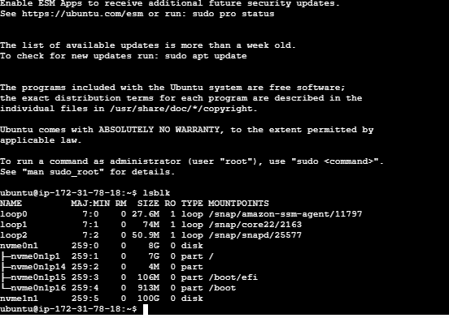

Note: Ensure that the EBS volume and the EC2 instance belong to the same Availability Zone, as cross-AZ attachment is not supported.

b)Procedure: increasing/decreasing of CPU and RAM
Step 1. - Navigate to the EC2 dashboard.
Step 2. - Stop the EC2 instance associated with the EBS volume.
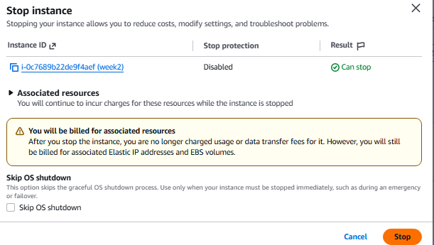
Step 3. - Click "Actions" and then—instance settings—change the instance type"Modify Volume".
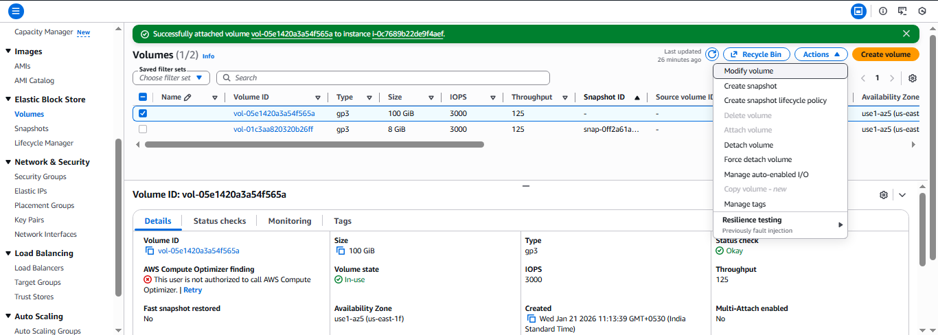
Step 4. -Increase/ decrease the size or change the volume type to a higher performance specification.
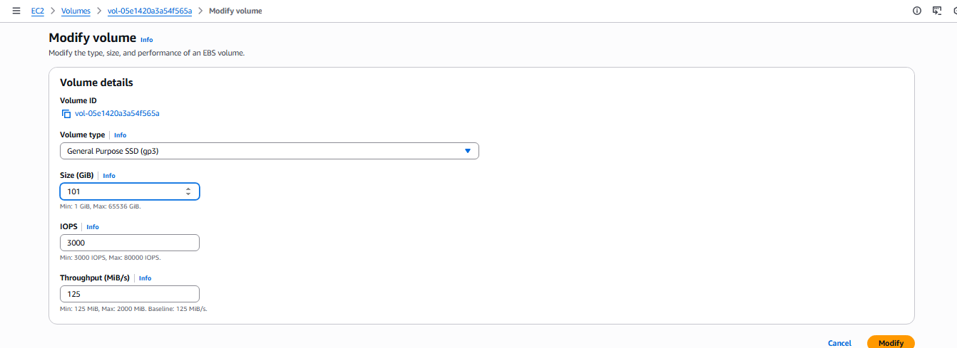
Step 5. - Click "Modify" to apply the changes.
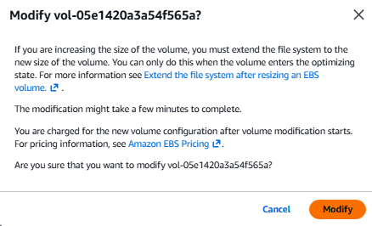
Step 6: Now the start the machine you see with increase /decrease of size and performance

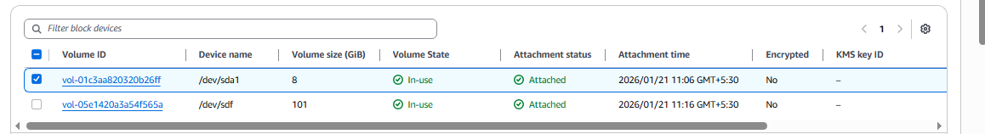

2.Attach and permanently mount an EBS volume to a Linux EC2 instance to ensure data persistence across reboots.
Objective
Attach an additional EBS volume (example: 20 GB) to a Linux EC2 instance and mount it using the system-default device names that appear on modern EC2 (Nitro) instances.
Note: Although you select a device name like /dev/xvdf in the AWS Console, the OS typically shows the disk as NVMe devices such as /dev/nvme1n1 and partitions as /dev/nvme1n1p1.

Step 1: Create an EBS Volume
- Log in to AWS Management Console
- Go to EC2 → Volumes
- Click Create volume
- Choose:
  - Volume type: gp3 (recommended)
  - Size: 20 GB (example)
  - Availability Zone: Same AZ as the EC2 instance
  - 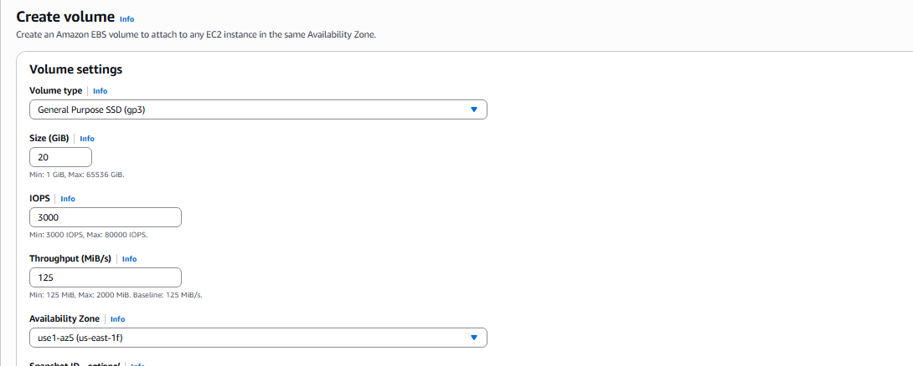
- Click Create volume

Step 2: Attach the EBS Volume to EC2
- Select the newly created EBS volume
- Click Actions → Attach volume
- Choose:
  - Instance: Your Linux EC2 instance
  - Device name (console level): /dev/xvdf
  - 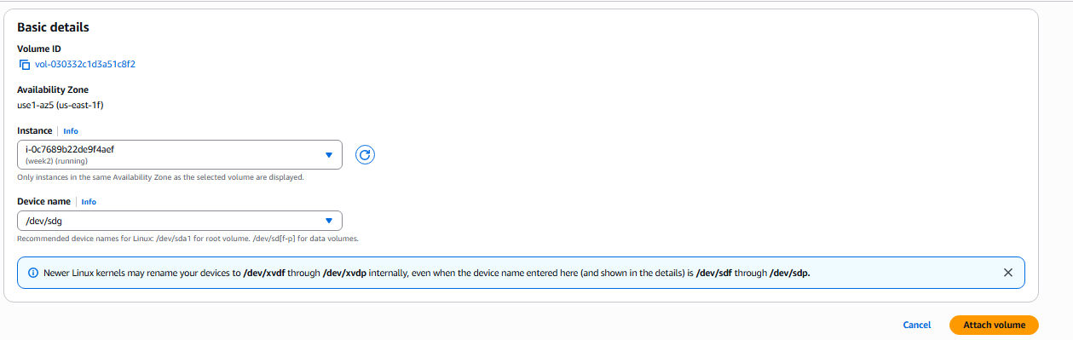
- Click Attach
Internally, Linux will expose this as an NVMe device (for example /dev/nvme1n1).

Step 3: Connect to the EC2 Instance
Connect using SSH:
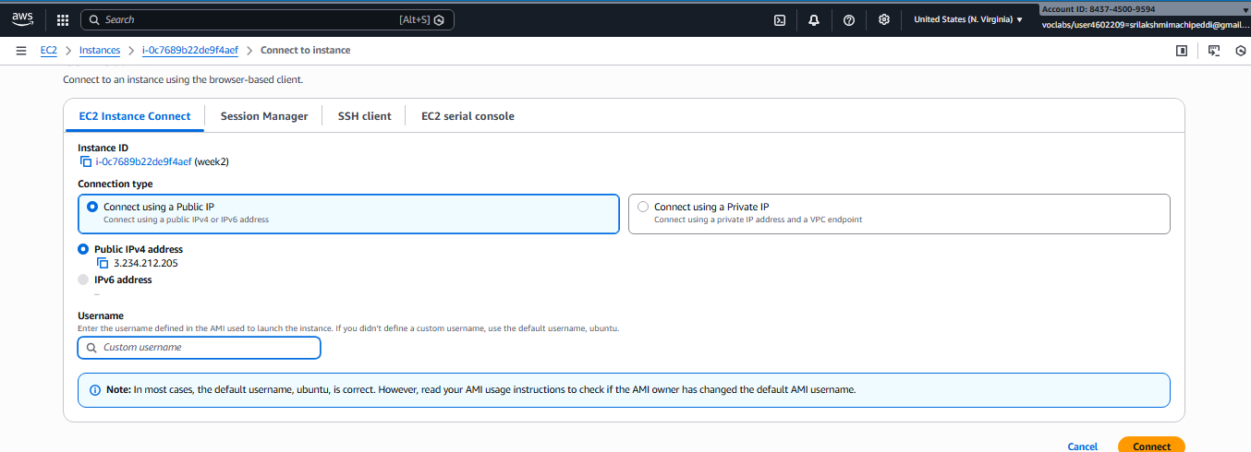
ssh -ikey.pem ec2-user@<public-ip>

Step 4: Verify the Attached Disk
List all block devices:
lsblk
You will typically see:
- Root volume: /dev/nvme0n1 (with partitions like nvme0n1p1)
- New EBS volume: /dev/nvme1n1 (no partition yet)
- 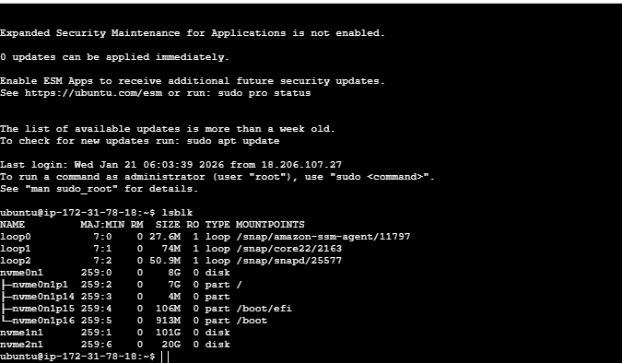

Check filesystem information:
lsblk –fs
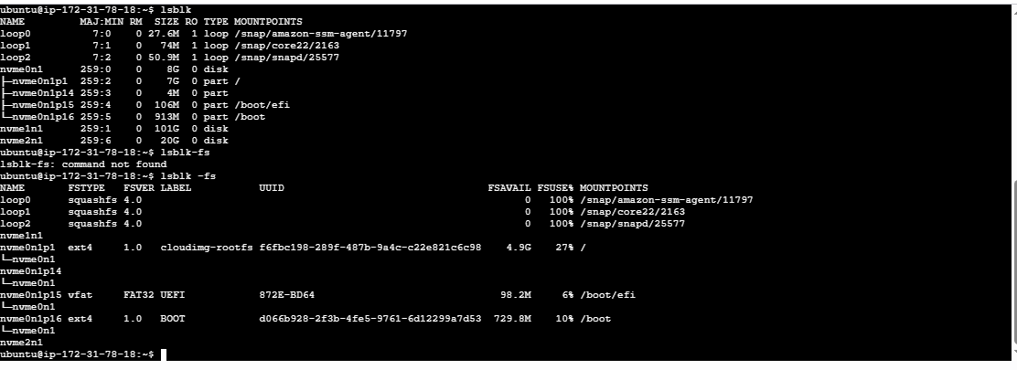

Step 5: Create a Partition on the New Volume
Create a partition on the unpartitioned disk:
fdisk /dev/nvme1n1
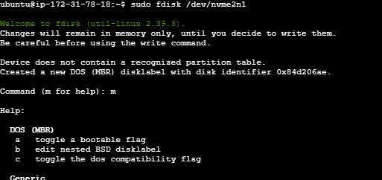
Inside fdisk:
- Press m → Help menu
- Press n → New partition
- Press p → Primary partition
- Press Enter → Default partition number
- Press Enter → Default first sector
- Press Enter → Default last sector (use full disk)
- Press w → Write changes and exit
- 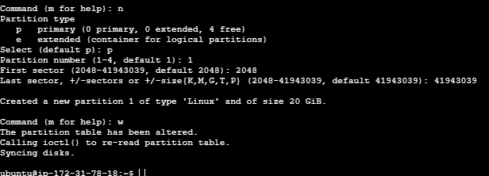
Notify the kernel:
partprobe

Step 6: Verify the New Partition
lsblk -fs
You should now see:
- /dev/nvme1n1p1
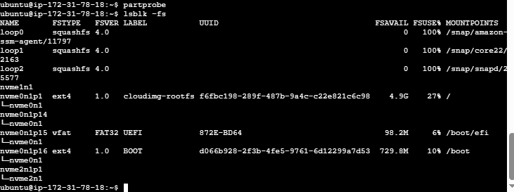

Step 7: Format the Partition
Format the partition with XFS filesystem:
mkfs.xfs /dev/nvme1n1p1
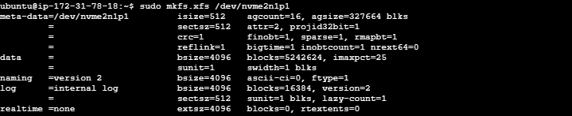
Verify:
lsblk –fs
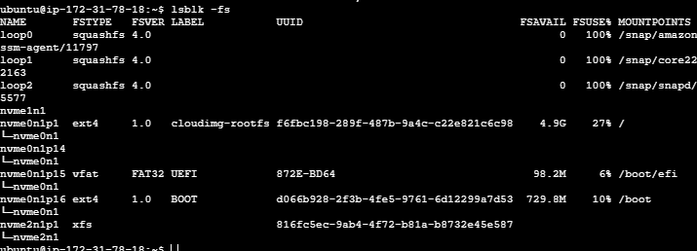

Step 8: Create a Mount Directory
mkdir /mnt/archana

Step 9: Mount the Volume
mount /dev/nvme1n1p1 /mnt/archana
Verify:
df -h
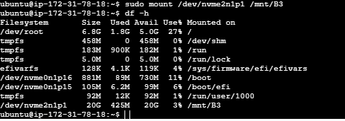

Step 10: Make the Mount Persistent (fstab)
Get the UUID:
blkid /dev/nvme1n1p1
Example output:
UUID="816fc5ec-9ab4-4f72-b81a-b8732e45e587"
Edit /etc/fstab:
nano /etc/fstab
Add this line at the end:
UUID="816fc5ec-9ab4-4f72-b81a-b8732e45e587"/mnt/B3xfsdefaults,nofail 0 0
Save and exit.
Test the entry:
mount -a
navigate to cd /mnt/archana
create the files here
touch f1
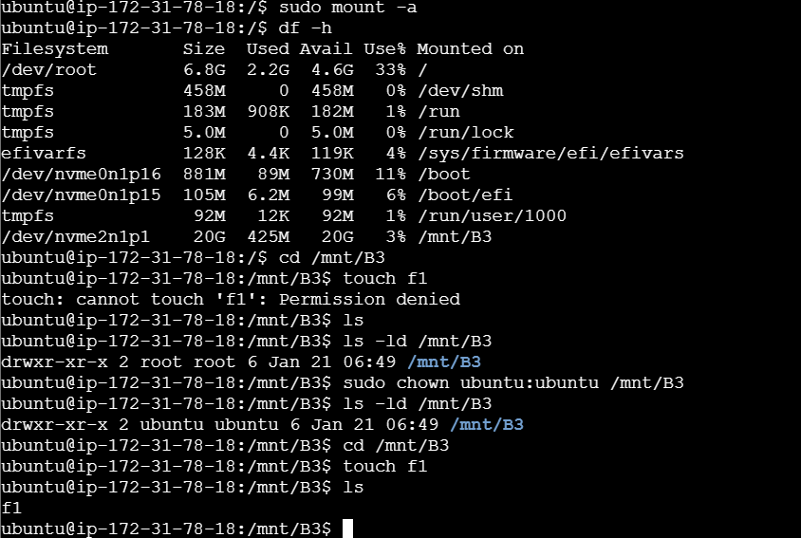

Step 11: Verify Persistence
- Reboot the instance:reboot
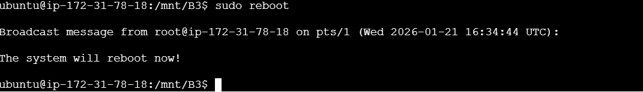
- Reconnect and check:df –h
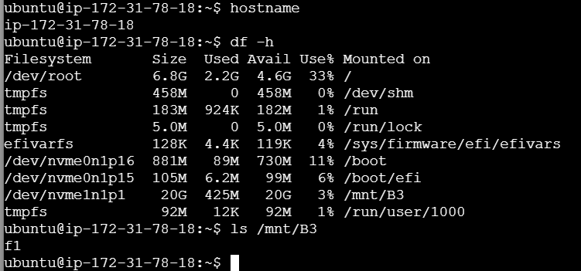
➡️ The volume should mount automatically.

Step 12: Detach and Reattach Volume (Data Recovery Scenario)
Detach the Volume
- EC2 → Volumes → Select volume
- Actions → Detach volume

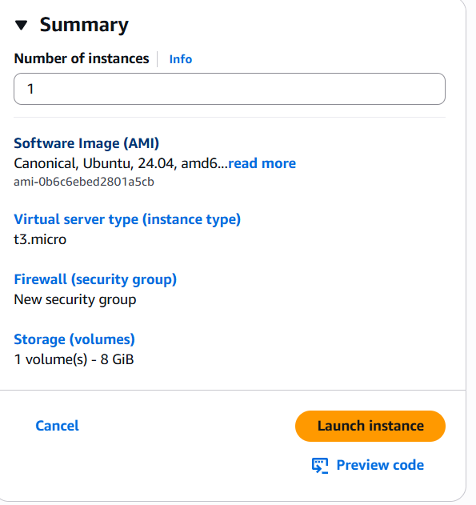

Attach to Another EC2 Instance (Same AZ)
- Attach the volume to a new instance
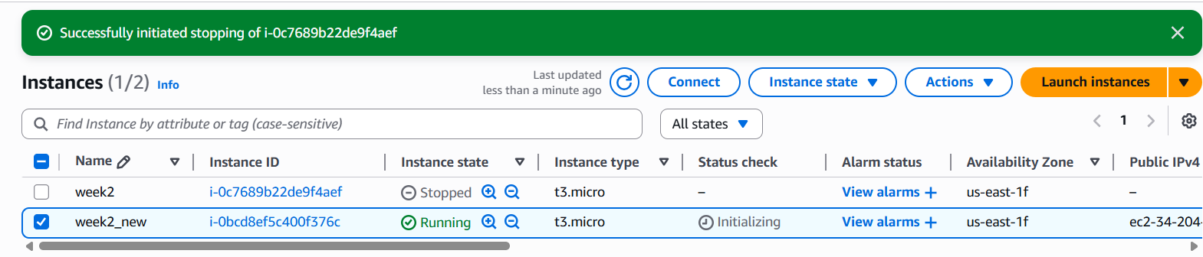
- Log in to the new instance
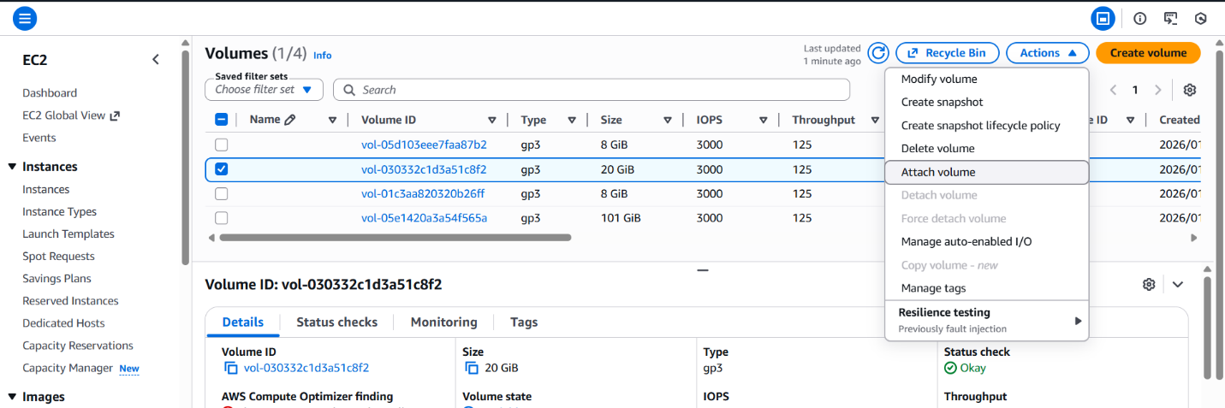
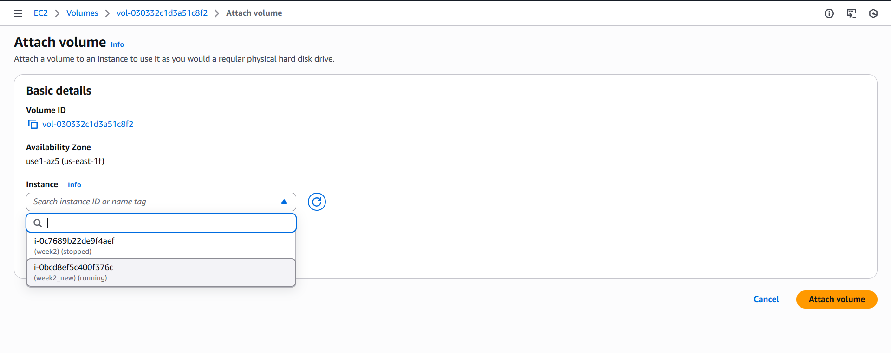
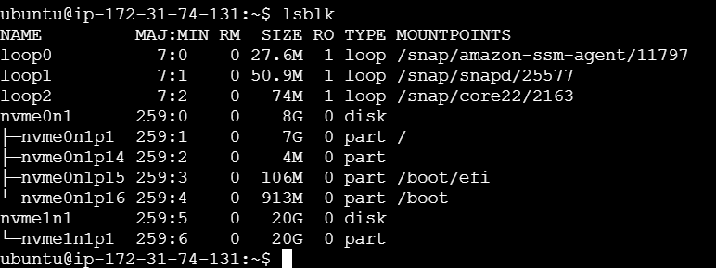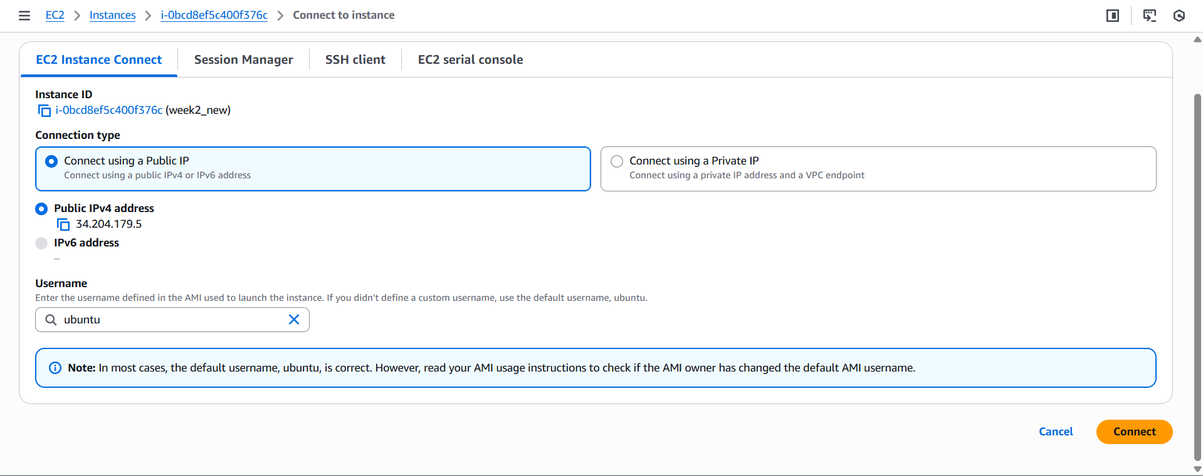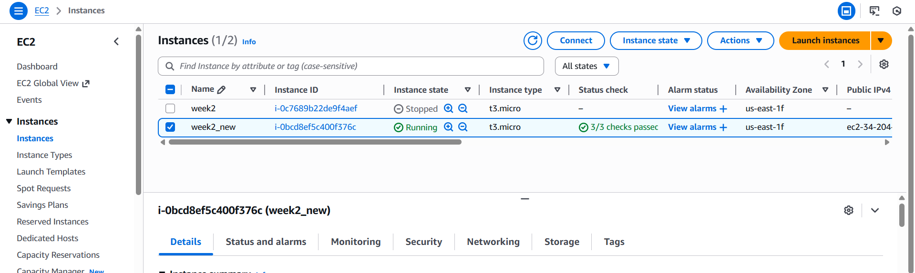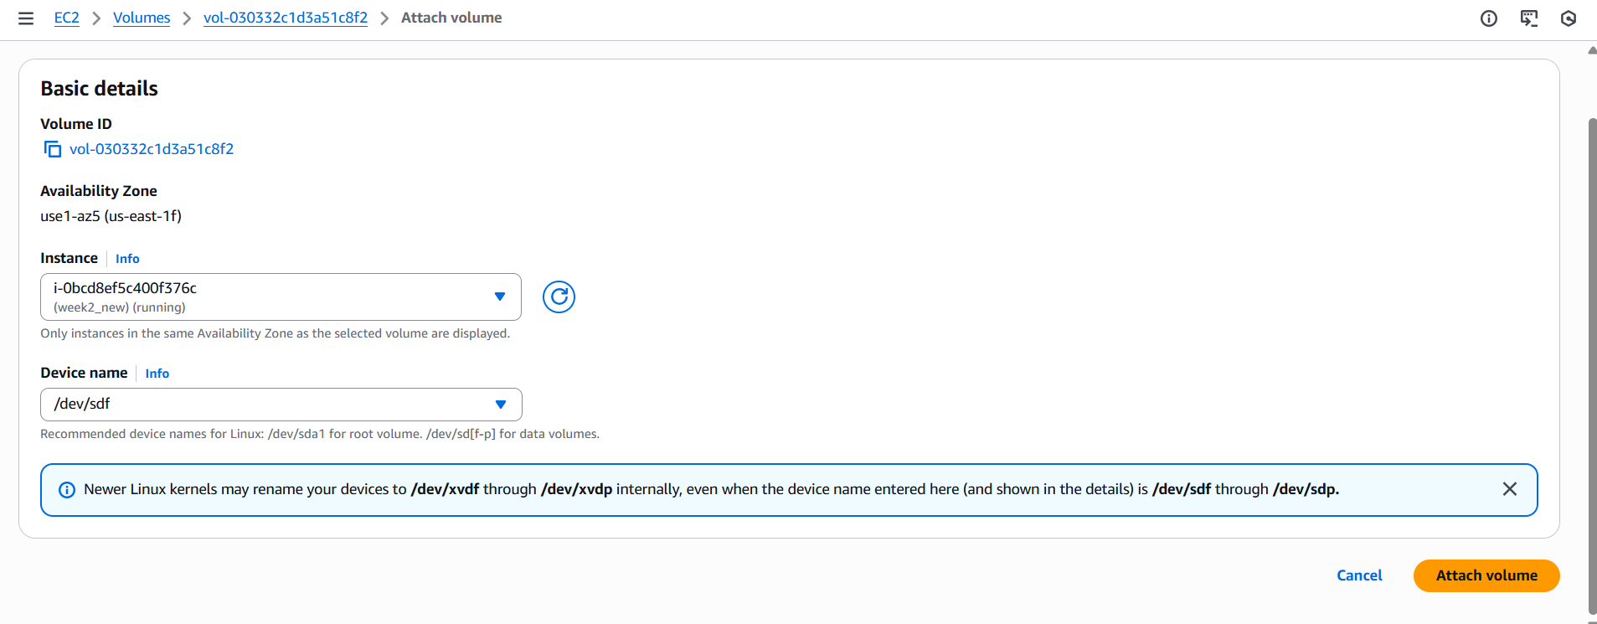
- Create mount directory:
mkdir /mnt/archana

- Mount the existing partition:
mount /dev/nvme1n1p1 /mnt/archana
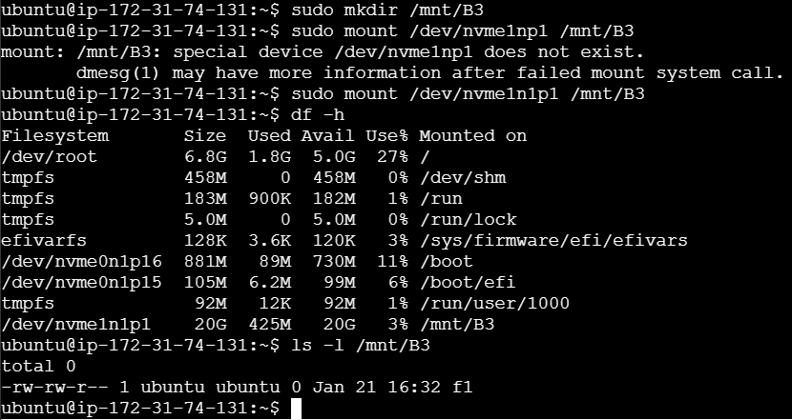
✅ All previously stored data will be available.

Summary Flow
Create Volume → Attach → lsblk → fdisk → mkfs → mkdir → mount → fstab → reboot

3. Create a snapshot of the attached EBS volume and use it to create and attach a new volume to an EC2 instance in another AWS region.
Attaching Volumes across regions of EC2 using the snapshot
To create a snapshot of an EBS volume and attach it to an instance in another region in AWS, you'll need to follow these steps:

Step 1. Create a Snapshot:
a. Sign in to the AWS Management Console.
b. Navigate to the EC2 Dashboard.
c. Click on "Volumes" in the left-hand navigation pane.
d. Select the EBS volume you want to create a snapshot of.
e. Click on the "Actions" dropdown menu above the volume list and select "Create Snapshot."
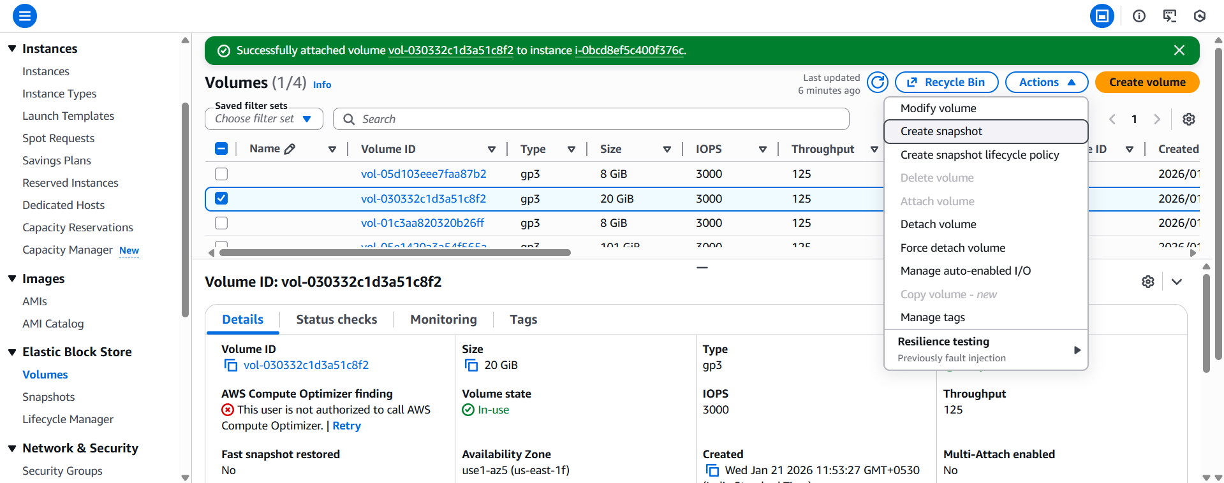
f. Provide a name and description for the snapshot.
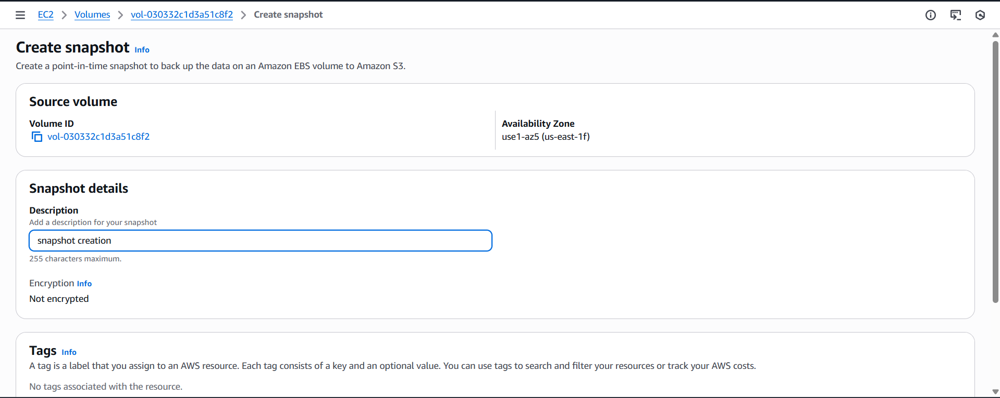
g. Click on the "Create Snapshot" button to initiate the snapshot creation process.
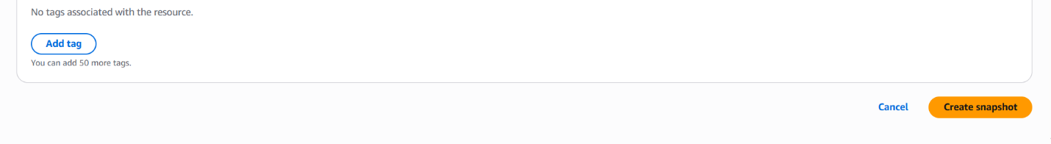

Step 2.Copy the Snapshot to Another Region:
a. Once the snapshot is created, go to the "Snapshots" section in the EC2 Dashboard.
b. Select the snapshot you just created.
c. Click on the "Actions" dropdown menu above the snapshot list and select "Copy Snapshot."
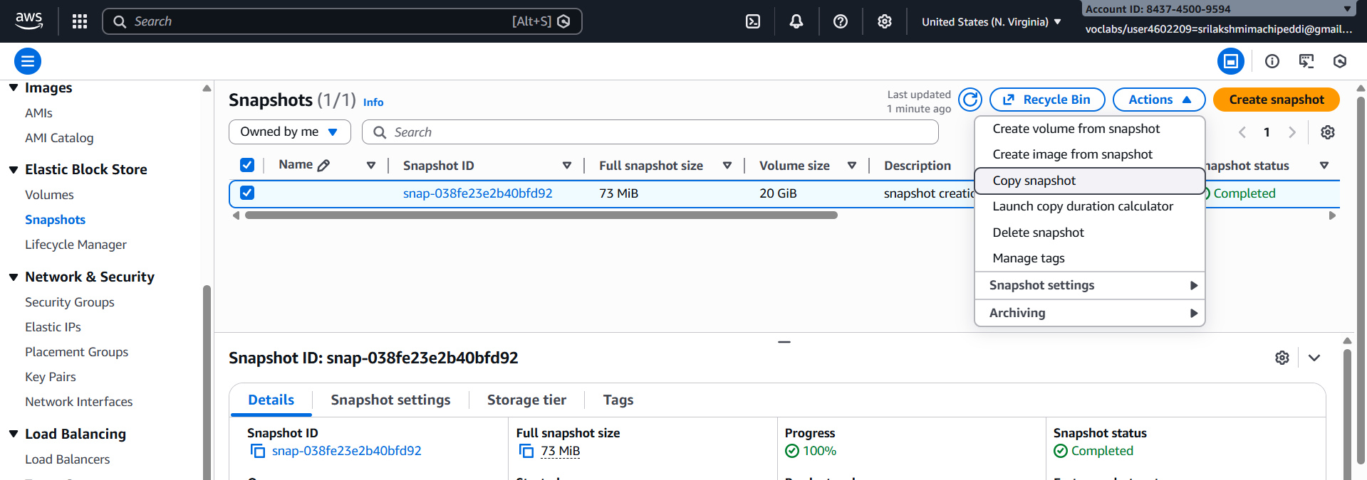
d. Choose the destination region where you want to copy the snapshot.
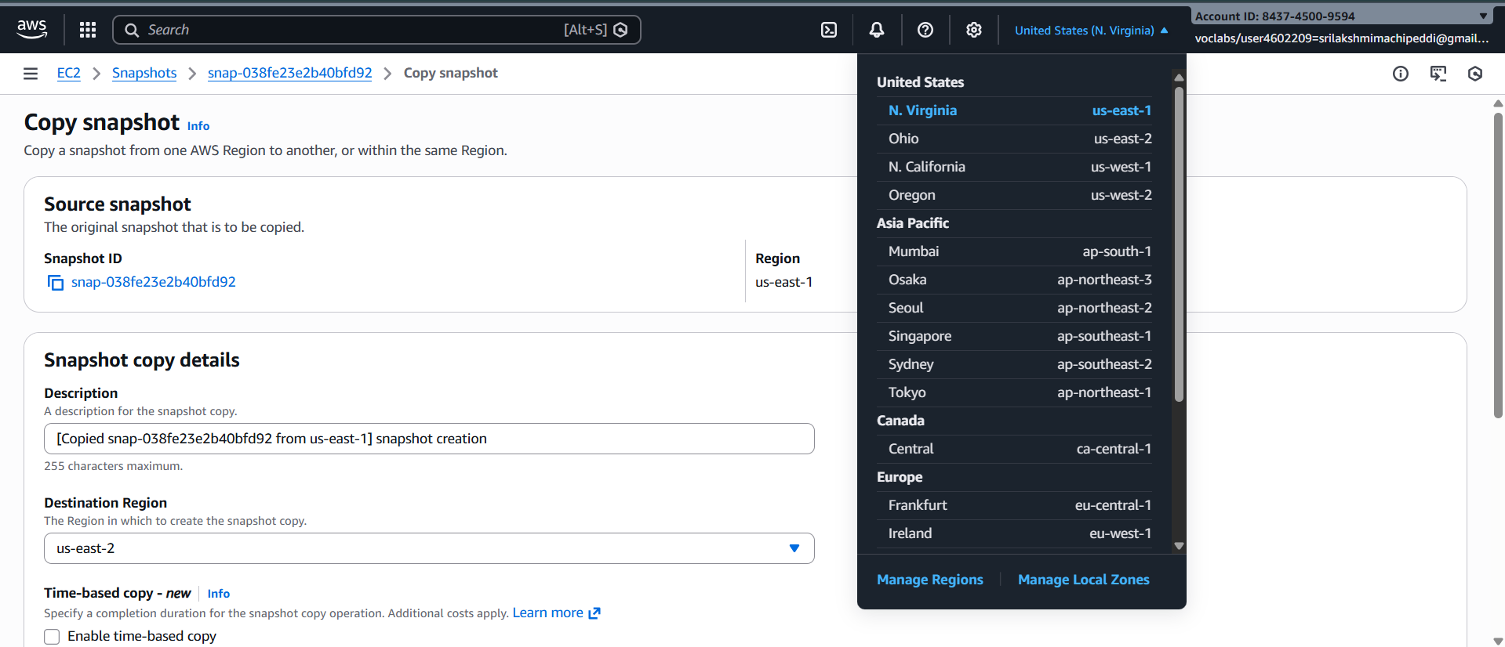
e. Click on the "Copy Snapshot" button to initiate the copy process. This may take some time depending on the size of the snapshot and the network speed.

Step 3. Monitor the Snapshot Copy Progress:
a. You can monitor the progress of the snapshot copy by navigating to the "Snapshots" section in the EC2 Dashboard of the source region.
b. Look for the snapshot you copied and check its status. It will change from "pending" to "completed" once the copy process is finished.

Step 4.Switch to the Destination Region:
- Use the region selector in the top-right corner of the AWS Management Console to switch to the destination region where you copied the snapshot.

Step 5. Create a Volume from the Snapshot:
a. In the EC2 Dashboard of the destination region, go to the "Snapshots" section.
b. Find the snapshot you copied from the source region.
c. Click on the snapshot, then click on the "Actions" dropdown menu and select "Create Volume."
d. Configure the volume settings, such as volume type, size, and availability zone.
e. Click on the "Create Volume" button to create the volume from the snapshot.

Step 6. Create the ec2 instance &Attach the Volume to an Instance:
a. Once the volume is created, navigate to the "Volumes" section in the EC2 Dashboard.
b. Find the newly created volume and select it.
c. Click on the "Actions" dropdown menu and select "Attach Volume."
D the EC2 instance to which you want to attach the volume and specify the device name.
e. Click on the "Attach" button to attach the volume to the instance.

We have created a snapshot of an EBS volume, copied it to another region, created a volume from the snapshot, and attached it to an instance in the destination region.

